Psalm 23: The Lord is my Shepherd

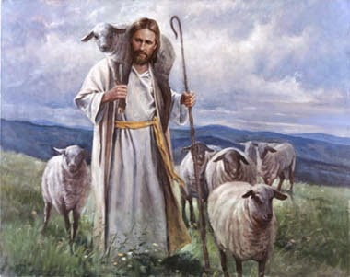
Psalm 23 is one of the more famous psalms written by David the King. This was the same David who fought Goliath with a slingshot and some smooth stones.
David was now King but he was also a musician and liked to write poems and songs. This particular psalm is about God being his Shepherd-King.
Keep in mind that David used to be a shepherd. He remembers how he led and cared for a herd of sheep.
At first thought a King and a Shepherd are very different. However there is also something that a Shepherd and a King have in common too. They both take care of something. A King is supposed to look after and protect the kingdom of people under him and a Shepherd looks after and protects his herd of sheep. They both have an important job.
David knows that God isn't like the kings on earth so he compares Him to a loving shepherd taking care of his people so we can get a better picture of what God is like.
When we read this Psalm we see ourselves as the sheep and God as our shepherd.
God is guiding us, protecting us and He loves us. 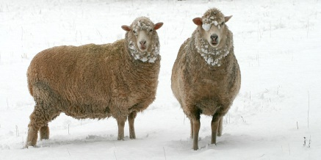

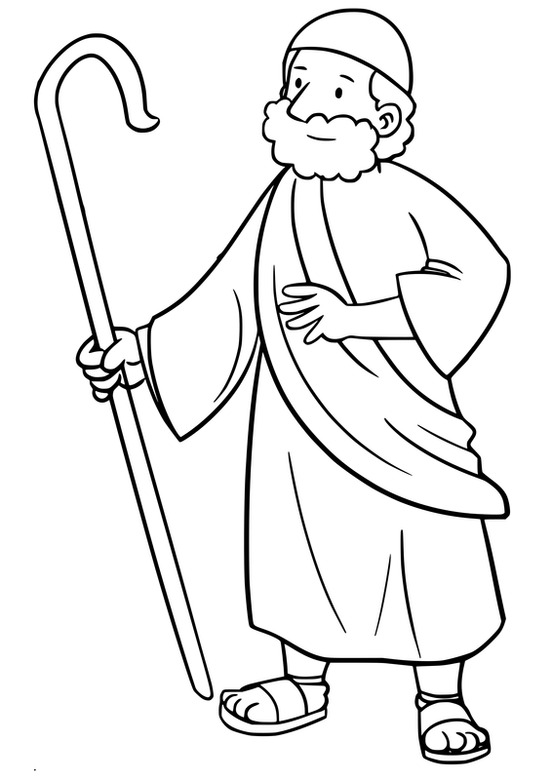

Lyrics
¹ The Lord’s my shepherd, I’ll not want.
² He makes me down to lie
In pastures green: he leadeth me
the quiet waters by.
³ My soul he doth restore again;
and me to walk doth make
Within the paths of righteousness,
ev’n for his own name’s sake.
⁴ Yea, though I walk in death’s dark vale,
yet will I fear none ill:
For thou art with me; and thy rod
and staff me comfort still.
⁵ My table thou hast furnished
in presence of my foes;
My head thou dost with oil anoint,
and my cup overflows.
⁶ Goodness and mercy all my life
shall surely follow me:
And in God’s house for evermore
my dwelling-place shall be.

Notes: Old English is used here so look at the modern meaning:-
Pasture- a green field Leadeth – leads Doth – does Dost – Do
Righteousness- the correct or right thing to do E’en- even Yea – yes
Vale – valley Art – are Rod and staff- a stick and a shepherd’s crook
Thou – you Thy –your Hast- has
Furnished – given me food to eat Foes – enemies Dwelling-place – Home, where I live
